Rodgers Forge Community Association
Architectural Covenants & Guidelines

Introduction

When the James Keelty Company, Inc. planned and developed Rodgers Forge, the Company inserted covenants and restrictions in all property deeds to establish and maintain the quality and character of the community. The covenants were recorded and as property is purchased and resold, each new owner accepts the covenants as a stipulation of the transfer of property ownership.

The covenant sets standards for the development of property and any exterior change or alteration. It has protected the aesthetic environment of our neighborhood and is key to the maintenance and improvement of our property values. The protection provided through the covenant is an important element in attracting residents to Rodgers Forge and assuring that it is an outstanding place to live.

Further affirmation of the unique architectural character and value of the exterior features of the Rodgers Forge community homes was confirmed with its designation as a National Register Historic District. As such these guidelines recognize and incorporate the Secretary of the Interior Standards for treatment of Historic Properties as appropriate.

“NO RESIDENTIAL STRUCTURE SHALL BE ERECTED, PLACED OR ALTERED ON ANY BUILDING PLOT IN THIS SUBDIVISION UNTIL THE EXTERNAL DESIGN AND LOCATION THEREOF HAS BEEN APPROVED IN WRITING BY THE JAMES KEELTY REALTY CORPORATION, ITS SUCCESSORS AND ASSIGNS”

The foregoing statement or similar statement appeared in all original property deeds for Rodgers Forge homes. The community association became the successors to the Keelty Corporation when the James Keelty Company, Inc. assigned and transferred all powers and rights to enforce any and all restrictions imposed on the entire development known as Rodgers Forge to the Rodgers Forge Community, Inc. (also commonly called the Rodgers Forge Community Association (“RFCA”)) by deed and agreement on January 18, 1960. This deed and agreement is recorded in Baltimore County Land Records Liber 3666, Page 357. Each year, the Board of Governors of the Rodgers Forge Community, Inc. appoints an Architectural Committee, which is authorized to approve or disapprove any and all alterations to the exterior of homes in Rodgers Forge. The committee follows established procedures for accepting and reviewing requests for alterations to the homes.

Slightly differing design features emerged in the construction of the various stages of the Rodgers Forge development as it was being built. This sometimes causes confusion as to what particular changes and alterations are acceptable for a specific home. Over many decades, patterns of approval for various Rodgers Forge subsections by the Architectural Committee have been established and these currently constitute the norm. It should also be noted that features that were approved in the past might not be acceptable today due to not testing well over time or the changing tastes of the community. The information contained in these architectural guidelines are a result of the dynamics of the general consensus of the community as a whole, as interpreted by the RFCA Architectural Committee. The dictates of the covenants and restrictions now enforced may, therefore, be said to comprise the combination of: Baltimore County Code, Baltimore County Zoning Restrictions, tenets of the original Rodgers Forge Covenants that have been continually applied and the whole history of decisions by the Architectural Committee resulting from applications for changes submitted by Rodgers Forge homeowners dating from 1960 to the present.

The following guidelines form the basis for decisions made by the Architectural Committee. Please note that the guidelines are subject to change. The standards should serve as only a guide for your reference. RFCA does not waive, release, or disclaim its right to enforce or defend the Rodgers Forge property covenants. The homeowner is responsible to obtain the approval of the Architectural Committee before any exterior modification commences. Any expenses associated with modifying or removing unapproved or nonconforming exterior modifications will be the sole responsibility of the homeowner.

Basic Procedure When Applying for Changes

The basic procedure to apply to the RFCA for authorization to make exterior home changes is as follows:
- Step 1 (Preliminaries): The homeowner creates a plan for the change that is consistent and compatible with other homes in the vicinity of his/her home. Homeowners may wish to discuss such plans with neighbors in order to gauge their reaction. Homeowner should communicate with the contractor(s) performing the work to convey applicable architectural guidelines and determine if a Baltimore County building or related permit is required for the exterior change. RFCA is not a code enforcing agency, and as such does not comment on structural safety, code permitted and compliance with State and local laws and regulations.
- Step 2 (Application): Prepare an application that abides by the architectural guidelines, with supporting materials, as needed, to be submitted to the RFCA. If the project requires a building or related permit, applicants must submit the permit as a part of the initial application or as a supplement if seeking RFCA review prior to obtaining the permit.
- Step 3 (Submitting the Application): Submit the application to the Architectural Committee. Once the application is received, the homeowner is notified of its receipt via E-mail.
- Step 4 (Decision): The Architectural Committee will review the application and may ask for additional information. Following review, the request will be approved, approved with modification or conditions (e.g. pending submission of a permit), or denied.
- Step 5 (Decision Notification): If the project was approved, a letter or email will be sent to the homeowner in a timely manner; and the homeowner may begin work immediately upon obtaining the approval notification. If the project was approved with conditions or modifications, the homeowner may begin work after fulfilling any applicable conditions or modifications (e.g. submitting a permit) as determined by the Architectural Committee.
- Step 6 (Denials): If the Architectural Committee denies the application (or parts of the application) a letter or email from the Architectural Committee will be sent to the homeowner in a timely manner stating specifically the reasons for the denial.
- Step 7 (Appeals): If the decision is denial, or if the homeowner wishes to request review of the conditions or modifications made by the Architectural Committee, the homeowner may appeal via email or phone to the President, or Vice-President of the RFCA., by 9:00 PM on the Monday prior to the next regular meeting of the Board of Governors, to ask that the homeowner’s appeal be placed on the agenda for the meeting, which is generally held on the second Wednesday of every month.
- Step 8 (RFC, Inc. Board’s Role in Appeals): At the regular monthly Board meeting of the RFCA, a representative of the Architectural Committee will briefly present the Committee’s view of the proposal and specifically state the reasons for the denial. This portion of the meeting is restricted to members of the Board of Governors. After the closed session, any homeowner making an appeal may then briefly present the reasons they believe their proposal meets the architectural standards of Rodgers Forge, and present reasons as to why their proposal should be allowed. The Board-at-large will ask questions of the homeowner then go into closed session for discussion on the proposal brought by the homeowner, and then will vote on the appeal.
- Step 9 (RFC, Inc. Board’s Decision on an Appeal): The decision, by majority vote of the Board, is considered the final action of the Board. The homeowner may request, or the Board may on its own motion decide, to hold the final decision until the following month, in order to permit further discussion or modification.

Architectural Guidelines

General
Where exterior modifications are not explicitly referenced in the architectural guidelines, it is at the discretion of the Architectural Committee, in consultation with the RFCA Board, for review and approval (see also “Absence of Guideline”). ANY modification(s) to the exterior of a house MUST BE SUBMITTED for review.

Applying for RFCA review and approval is in addition to applying for a Baltimore County building or related permit if required under applicable law. For any exterior changes that require a building or related permit (i.e. fences, decks, retaining walls, solar panels, etc.), the homeowner must submit a copy of the Baltimore County building or related permit to RFCA as a part of their initial application or as a supplement if seeking RFCA review prior to obtaining the permit.

For projects that will result in significant dust, noise, fumes, or other potential impact, homeowners are strongly encouraged to reach out to their immediate neighbors to appraise them of the project prior to initiation.

Additions to Homes
- Additions are not permitted. It is the responsibility of the RFCA to preserve the original home designs as integral to its primary mission “to maintain, enhance, and protect the high standards of the Rodgers Forge neighborhood.” Additions include, but are not limited to, porch enclosures, modifications with foundations, garages, sun rooms, roof modifications, etc.

Awnings
- Canvas awnings must be in solid dark green color (often called “Evergreen”).
- If installing an ice sheet for winter, it must be clear, or solid dark green or white. No application is required.
- If installing shade/fabric awnings on an existing frame, no application is required.

- If adding any new structural framing for the attachment of awnings/shade fabrics, the following must be submitted:
  - Product data for selected model/fabric; and
  - Drawing(s) indicating the location on house to receive awnings.
  - Photos of the property showing area of proposed awning.

- Retractable awnings are only allowed on the rear of Rodgers Forge. Applications for awnings in the rear of homes should show dimensions including placement height on rear wall and outward projection.

Decks
- Prior to beginning any construction, applicants must confirm with Baltimore County if a building or related permit is required, and if so required, secure the appropriate permit. Permits are generally required for deck construction. Click here for Baltimore County's Deck Construction Guidelines.

- Applications to the RFCA for decks shall include:
  - An aerial site plan showing the proposed location of the proposed deck on the property with dimensions and position as close to scale as possible, showing the rear yard, as well as all existing structures including: garage, fencing, porches, paving, walkways, alleys and the rear wall of the house.
  - Pictures and manufacturer’s specification for proposed deck.
  - Photos of the property showing area of proposed deck.

- Location and Materials: Decks are allowed only in the rear area of the house and must be constructed of wood or composite wood materials. Railings must be same or similar material to the deck. Decking material must be natural wood color (or stained a natural wood color).

- Maximum Width of Decks: A deck may not be wider than the width of the home, less 18” from the side property line (when adjoining an inside-of-group home) and less 6” from the side wall of the house if the property is an end-of-group.

- Maximum Depth of Decks: Decks may extend up to 12 feet from the home’s rear wall, plus up to a 4’x4’ landing for stairs.

- All decks must be open projections on 3 sides and may not have a roof of any kind or be enclosed. Wood lattices with at least 2” squares are generally permitted to be installed on the sides of elevated decks to enable limited privacy and/or plant growth. Solid or spaced boards/fences are not permitted. Lattices cannot exceed six feet in height measured from the floor of the deck.

- Lattices under the deck are permitted but not encouraged as it has been found that they promote pest harborages.

- Decks 4 feet in height or lower must have rodent wire, gravel, or concrete beneath the deck to prevent pest harborages.

Doors
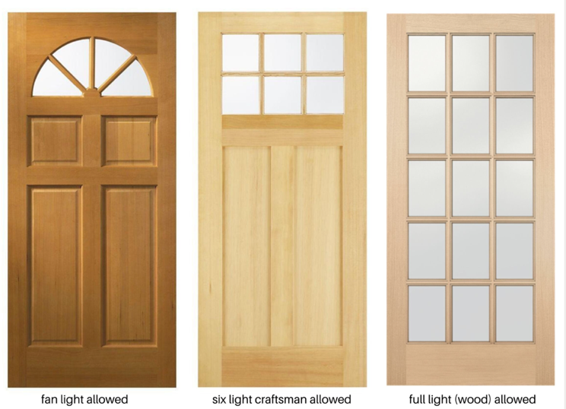

- Full, divided-lite front doors must be real wood doors with divided lite or simulated divided lite construction only. Only door styles matching original 12-lite or 15-lite front doors found in Rodgers Forge will be acceptable (see attached images). Full-lite front doors comprised of steel, fiberglass composite, or other materials with artificial grilles between the glass will not be permitted for front doors. If door construction other than wood is desired, one of the other approved door styles (Craftsman 6-lite or half-round) should be considered.

- All door products must be high quality wood, metal-clad, or fiberglass construction. Vinyl construction door products will not be approved.

- Trim: The window and door trim around the new doors must be inset in the rough openings and match the existing trim style. Trim that is different than existing will not be approved.

- Application documentation must include pictures and manufacturer’s specifications for proposed door(s); and photographs of house showing door(s) to be replaced.

- Homeowners may apply to replace dining room windows or kitchen door on the rear of the home with French doors or sliding doors provided that the following conditions are met:

  - Scale drawings: Architectural quality, scale, dimensioned elevation drawings accurately showing the existing conditions and proposed changes to the rear of the house must be submitted. Note that you do not have to hire an architect to meet this requirement, but the drawings need to be prepared by a professional (e.g., contractor) to construction industry standards.

- Rough opening height: Most existing rough opening lintel elevations are higher than standard-height door products. Only two options will be considered. 1) full-height custom door product or, 2) a transom lite above new standard-height door(s).

- Standard-height doors that fall short of the rough opening height, with a gap in-filled with ‘blank’ wood trim panel will not be allowed.

- Proposed window and door products, whether 'french' or ‘sliding,' must have divided lites or muntins as per the general window and door guidelines.

- Product data: The product catalog sheet to include an image of the proposed door product and door hardware to be installed must be submitted with the application for approval. If the door product does not fit the existing rough opening height from finished floor to lintel, the product data for a transom lite (transom window) to be installed above the door(s) must be submitted. If the existing back door (Kitchen) is intended to be replaced with a window, product data for new Kitchen window(s) should also be provided.

- Other door replacements, including storm doors and garage doors, are required to be of high quality and be compatible with the general architectural design and appearance of the community. Security doors are not permitted. Garage doors must be white with white trim.

Fences
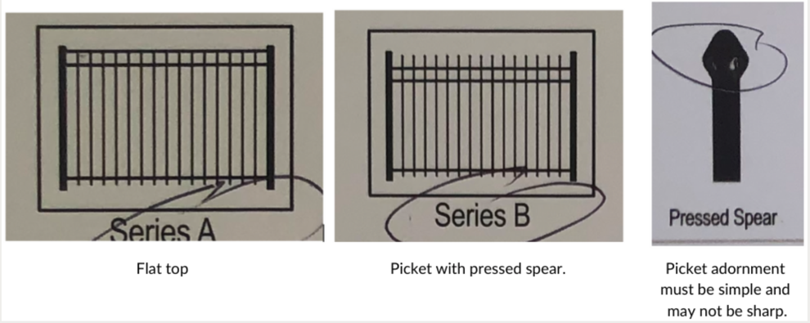
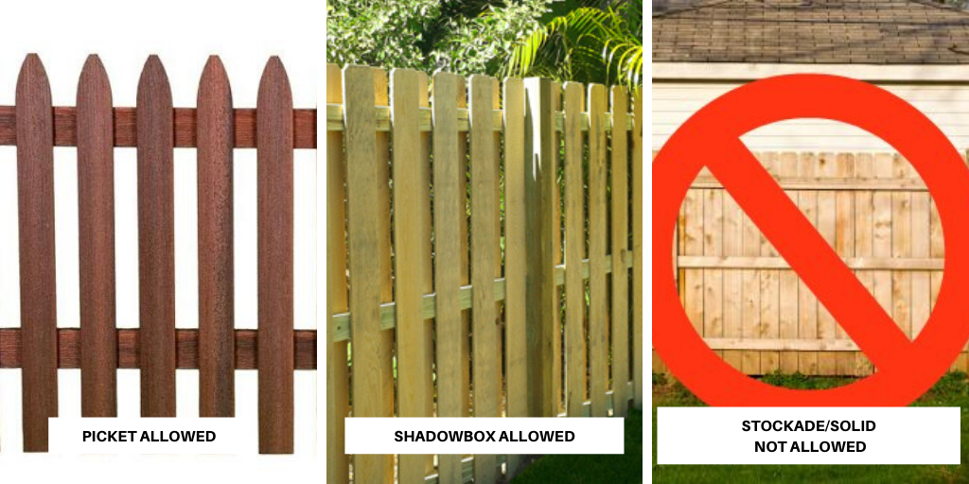

- Prior to beginning any construction, applicants must confirm with Baltimore County if a building or related permit is required, and if so required, secure the appropriate permit. Baltimore County Building Code requires any fence over 42” to apply for a building permit. There are additional County restrictions for end-of-block homes due to safety and traffic concerns in which fences may obstruct the vision of drivers and pedestrians as they round corners entering and exiting streets and alleys.

- Fences must be constructed of wood or composite wood materials, or black aluminum. Chain link fences are not a permitted type of fence, unless replacing an existing chain link fence.

- Wood fences must be wood shadowbox (double sided, alternating pickets attached to each side of the rail) or picket (single sided, pickets attached to the rail) style, and must include open space between the vertical boards to permit airflow. For shadowbox fences, open space between the vertical boards is required to be at least 2.0”. For all picket fences, open space between the vertical boards is required to be at least 0.5”. For reference, a “traditional” picket fence is between 36” and 48” in height and has at least 2.5” of spacing between vertical pickets. “Solid” or “Privacy” fences (typically 3/8” inches or less in between pickets or boards) are not permitted. Natural weathering is preferred to painting the fence any other color than white.

- Aluminum fences must be made of adequately strong and durable materials. Posts must be at least 14 gauge, pickets and top rails must be at least 16 gauge, gates must be at least 11 gauge. Fences must be black powder coated. Fences may be no more than 4 feet high. The style of fence allowed is either flat top or picket. The picket style may only have pressed spear adornments or a similar simple style.

- No fence over 6’ in height is permitted. This includes at locations between houses with elevated decks.

- Applications to the RFCA for fences shall include:
- An aerial site plan showing proposed location of the fence and gates on the property with dimensions and position as close to scale as possible, as well as all existing structures including: garage, fencing, porches, paving, walkways, alleys and the rear wall of the house.
- Fence and gate dimensions
- Pictures and manufacturer’s specification for proposed fence.
- Photos of the property showing area of proposed fence.

- Fences must be built as self-supporting structures, with posts anchored into the ground and a framework or substructure which then supports the actual boards.

- The unfinished side of the fence must face the homeowner’s property and not be visible to neighbors.

- Fences may not be constructed/installed in the front yards of houses, with the exception of small garden/decorative landscaping fences. Garden/decorative landscaping fences must not exceed 18” in height measured from the ground to the uppermost part of the fence. Garden/decorative landscaping fences must be of a quality and durable material (which does not include welded wire, chicken wire, chain link, snow fence, or other similar fences). Fencing must be unobtrusive with limited visual impact to adjacent properties and the right of way. Garden/decorative landscaping fencing may not be installed in a manner that serves to block or enclose a property. The installation of a garden/decorative landscaping fence does not require Architectural approval but RFCA reserves the right to demand its timely removal in its sole and absolute discretion if it violates the stated requirements.

- For end of group and end of block properties, fences higher than 42” may not extend towards the front of the house beyond a line even with the rear wall of the house. Fences that are 42” or less may extend to the front wall of the house and no further.

- Given the unique nature of houses on Pinehurst Ave, the following rules apply:
  - For the purposes of these Guidelines, for Pinehurst homes with entrances facing Pinehurst Ave, the “rear” wall of the home shall be considered the wall closest to the property’s alley, and the “front” wall shall be considered the opposite street facing wall.
  - In addition to the other fences specified above, traditional split rail wood fences are permitted to be installed along the Pinehurst Ave for aesthetic purposes, not to exceed 48”. To that end, the fence may not fully enclose the property (i.e. may not wraparound past Pinehurst Ave on to the non-Pinehurst street and cut in on the property line)

Flags
- Flag staffs/poles (not to exceed 5-6 feet) that are physically mounted to the home or garage (so long as they do not protrude into the public right of way) are permitted and do not require Architectural Committee approval.
- In-ground flag poles are not permitted in the front, rear, or side of the property.

Gutters/Downspouts
- Must be in keeping with original design and group harmony.

- Typical white or brown metal and copper gutters and downspouts are acceptable if they replace in kind.

Hot Tubs & Swimming Pools
- Hot Tubs or swimming pools are not permitted in Rodgers Forge yards, or on decks, porches, or patios.
- Small, temporary, inflatable or kiddy pools are permitted without an application to RFCA.

HVAC Units
- Exterior HVAC units must be placed in the rear of the house, except in the case of an end of unit in which a unit may be placed on the side of the house. HVAC units are not permitted in the front of a house. An application is not required to install a HVAC unit.

Painting

Repainting (or re-staining in the case of a deck) an existing fence, door, window, trim, or shutter does not require an application to RFCA if the color was previously approved per the below list of colors and is repainted in-kind. If the color has not been previously approved or the homeowner wishes to change the color, an application is required. If an application is required, applicant should submit a photo of the item to be painted and the proposed color.

- Window exteriors must be white.

- Shutters must be white or black.

- Doors are preferred to be white, black, or natural wood.

- Window and door trim must be white.

- Wood deck painting (other than white) is not permitted. However, it may be stained.

- Wood fences must be natural weathered or painted white.

- Porch, sidewalk, stairs, foundation, and other concrete painting is not permitted.

- If the requested color is other than white, paint chip must be submitted with application. Certain selected muted colors referred to as “Williamsburg” colors are generally acceptable for doors and shutters but not colors that approach the realm of the bright primary colors in the spectrum.

Parking Pads

Parking pads are permitted only in the rear of homes. The parking pad must be completely contained within the homeowner’s alley-side property line and must allow for vehicle clearance in the alley as required by the Baltimore County Code. The options are as follows (also see visualization below):
  - Option 1 – Property with a shared or individual garage – One (1) parking pad is permitted and must be parallel to the rear wall of the home and the alley.
  - Option 2a and 2b – Property with no garage – One (1) parking pad is permitted and must be parallel (preferred) or perpendicular to the rear wall of the home and the alley.
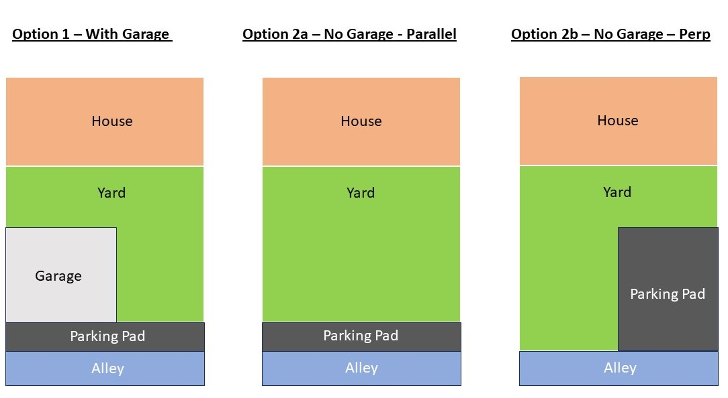

- Option 2b parking pad dimensions may not exceed 9 feet wide and 18 feet long and shall be at least 18” from the side property line (when adjoining an inside-of-group home) and at least 6” from the side wall of the house if the property is an end-of-group.

Materials of the parking pad must be concrete to match existing alleyway, permeable parking pavers rated for automobiles, or gravel/pebble installations. Asphalt is not permitted. Parking on grass/dirt is not permitted.

- Applications to the RFCA for parking pads shall include:
  - An aerial site plan showing the proposed location of the parking pad on the property with dimensions and position as close to scale as possible, as well as all existing structures including: garage, fencing, porches, paving, walkways, alleys and the rear wall of the house.
  - Pictures and manufacturer’s specification for proposed parking pad.
  - Photos of the property showing area of proposed parking pad.

Patios
- Prior to beginning any construction, applicants must confirm with Baltimore County if a building or related permit is required, and if so required, secure the appropriate permit. Permits are generally required if patios are more than 120 square feet.

- Applications to the RFCA for patios shall include:
  - An aerial site plan showing the proposed location of the patio on the property with dimensions and position as close to scale as possible, as well as all existing structures including: garage, fencing, porches, paving, walkways, alleys and the rear wall of the house.
  - Pictures and manufacturer’s specification for proposed patio.
  - Photos of the property showing area of proposed patio.

- Must be constructed in the rear yard only.

- Must be brick, masonry, concrete, flagstone, loose pebbles or stone chips.

- Must be even with the ground.

Retaining Walls
- The installation or repair/maintenance of retaining walls is permitted if required for site grading or soil stabilization.

- Approved materials for retaining walls include:
  - Stone with cap
  - Textured masonry units
  - Brick to match color/grout of house
  - Heavy timber

- Applications to the RFCA for retaining walls shall include:
  - An aerial site plan showing the proposed location of the retaining wall on the property with dimensions and position as close to scale as possible, as well as all existing structures including: garage, fencing, porches, paving, walkways, alleys and the rear or front wall (as applicable) of the house.
  - Pictures and manufacturer’s specification for proposed retaining wall.
  - Photos of the property showing area of proposed retaining wall.

Roofing
- Except as specified in this section (see below – bay windows/projection windows), applications are required for all roof replacements and maintenance/repair that impacts greater than 10% of the roof. Maintenance or repair of roofs that affects 10% or less of a roof does not require an application so long as the roofing material matches the existing roof and is replaced in-kind.

- The following are approved roofing materials:
- Natural slate (to match existing)
- CertainTeed Symphony (Colonial Gray color)
- Ecostar Majestic (Federal Gray color)
- CertainTeed Grand Manor (Colonial Slate color)
- GAF Camelot ll (Antique Slate color)
- CertainTeed Belmont (Colonial Slate color)
- Note – Timberline shingles are not permitted

- Flashing and rim of roofing must be one of the following:
  - Natural copper that will patina. Synthetic copper-look material is not permitted.
  - Black or grey to match existing roofing.

- For houses with bay window/projection windows, if the roof is being repaired or replaced, an application to RFCA is required. Replacement materials should match existing color.

- Applications to the RFCA for roofs shall include:
  - Manufacturer and color of roofing material
  - Picture of the roof being replaced
  - Description of the scope of work for roof work

Satellite Dishes
- Dishes should be no larger than 18” in diameter and must be located only on the rear roof of homes.

- Satellite dishes may not be visible from the front of the home. That is, no part of the dish should protrude above the top of the roofline.
- The installation of a satellite dish does not require Architectural approval but RFCA reserves the right to demand its timely removal in its sole and absolute discretion if it violates the stated requirements.

Sheds and Bins
- Sheds must be of wood, wood-like composite, or vinyl and have a footprint no larger than 65 square feet, and the walls may be up to 6’ not including peak. No metal sheds are allowed. A maximum of 6’ feet is allowed along the alley.

- Sheds may be placed only in the rear yard. Side-yard sheds or bins are not permitted under Baltimore County regulations.

- Sheds and bins are not permitted for homes that have garages.

- Applications to the RFCA for sheds and bins shall include:
  - An aerial site plan showing the proposed location of the shed/bin on the property with dimensions and position as close to scale as possible, as well as all existing structures including: fencing, porches, paving, walkways, alleys and the rear wall of the house.
  - Pictures and manufacturer’s specification for proposed shed/bin.
  - Photos of the property showing area of proposed shed/bin.

Siding
- New siding must replicate the original profile and board size.

Sidewalks and Porches
- Constructing a new screened or enclosed porch is not permitted.

- Screening in existing porches is not permitted.

- Porches must replicate the original dimensions when replaced.

- Porch and sidewalk railings must be wrought iron or aluminum (“metal”), and painted black. Alternative wood or wood composite railings may be permitted or white metal railings may be permitted if they are in alignment with the character of the block/group and do not disrupt the quality and character of the community. For example, homes with a covered front porch and white columns may be permitted to install matching wood or metal railings.

- Front and side street sidewalks must be concrete.

Solar Panels

Except as permitted herein, solar panels must be rear facing and roof mounted. To the maximum extent practical, solar panels may only be placed in areas that minimize their visibility from the public thoroughfare (i.e. road or street). Solar panels on a roof visible from a public thoroughfare (i.e. side roofs) will only be permitted if the property is a stand-alone or end of group unit and documentation is provided from the solar contractor indicating that this is the only feasible location for a solar array. Solar panels located on the front of a unit or mounted in the ground/yard are prohibited.

All components of the solar system should be integrated into the design of the home. Solar panels must not require alterations to significant or character‐defining features of a historic resource, such as altering existing rooflines or dormers. The color of the solar system components should generally conform to the color of the roof shingles and adjacent material to the extent practical.

Solar panel installations that are reversible are preferable but solar “shingles” that mimic the look of composite shingles are acceptable but must match the color of the current roof shingles to the extent practical. See Roofing in Architectural Guidelines.

Solar panels must be mounted no higher than 8 inches above the roof surface, and solar panels must be set at angles consistent with the pitch of the roof, keeping a low profile.

Solar panel systems must comply with Baltimore County building and fires codes including limitations on roofline offset.

Solar panels and equipment must have non-reflective finishes.

Piping and electrical connections must be located directly under and/or within the perimeter of the panels when possible, and placed as inconspicuously as possible when viewed from all angles.

In accordance with § 8-301 of the Business Regulation Article of the Annotated Code of Maryland, installation of all solar systems must be done by a Maryland Home Improvement Commission (MHIC) licensed home improvement contractor. See the Maryland Department of Energy’s A Maryland Consumer’s Guide to Solar for additional information.

Applications submitted to the Architectural Committee must include the following:

A diagram “drawn to scale” by the licensed contractor installing the system showing where the system will be installed.

Photographs of the house and roof area where the array will be mounted.

Proof of valid MHIC license for the contractor.

Material to be used and/or manufacturer’s description of the system, photos, and/or pictures of the system and color of the system.

Where possible, provide photos of similar existing systems as examples.

Temporary Structures
- For the purposes of these guidelines, a “Temporary Structure” is defined as a structure that is temporary or seasonal in nature and may be easily removed; and is not addressed elsewhere in these Guidelines.
- Temporary Structures such as tents (open or netted), horizontal sun sails, and children’s playground equipment are permitted in property rears to the extent that they are not a nuisance and do not materially interfere with an immediate neighbor’s use and enjoyment of their respective property. A Temporary Structure does not require Architectural approval, unless a permanent exterior change is required to support the Temporary Structure, but RFCA reserves the right to demand its timely removal in its sole and absolute discretion if it violates the stated requirements.
- Temporary Structures must be no wider than the width of the home, less 18” from the side property line (when adjoining an inside-of-group home) or less 6” from the side wall of the house if the property is an end-of-group (not end of block) home.
- Neighbors are strongly encouraged to communicate with their immediate neighbors prior to installing any Temporary Structures.

Windows and Dormers
1``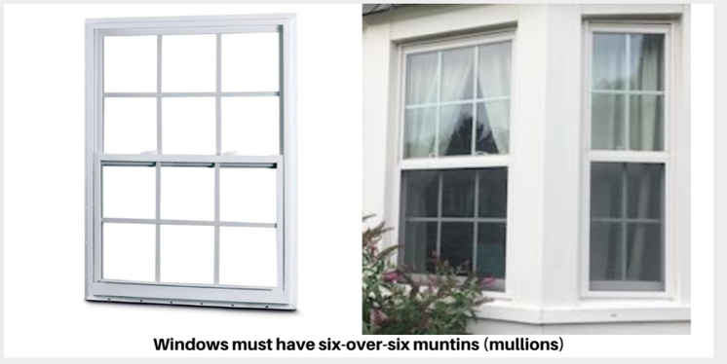
- Must be in keeping with original group and neighborhood design and replicate the original windows and doors of the home.

- Windows must be six over six muntins (mullions) in double hung standard windows.

- Glass must be clear; not tinted or decorative.

- The Mullions separating complete window units in a double window must be retained or duplicated.

- New bay windows where no windows currently exist, or bay windows that replace standard windows, are not approved. Replacement bay windows must replicate the original bay window.

- When replacing windows, it is important to retain decorative trim where it exists.

- Submit picture of home noting which windows are being replaced.

- New dormers are only permitted in the back of house; dimensions, style, and materials must be approved by the RFCA architecture committee in advance.

- Replacement of cladding on existing dormers shall match the existing material or be white Hardie Plank style siding.

Absence of Guideline
In the absence of a specific applicable provision in the RFCA Architectural Guidelines, a requested modification to the exterior of a property shall generally, to the extent practical, adhere to the original architectural design and style of the property and utilize the same or similar materials of high quality that were utilized on the property. The Board of Governors recognizes that many of the properties in RFCA are non-standard or unique, including stand-alone and end of group units. In such instances, the Architectural Committee will have discretion to review and, in consultation with the Board as appropriate, approve requested modifications that keeps with the community goal of preserving the overall historical design and style of the neighborhood as may vary by different groups of the neighborhood. The Architectural Committee may look to other nearby homes in the surrounding block of the property in an effort to ascertain the congruity of a proposed modification.

This policy may be not be utilized in the event the Architectural Guidelines explicitly prohibit a proposed exterior modification.

In the event the Architectural Committee identifies a trend in requested modifications that are not addressed, ambiguous, or unclear in the Architectural Guidelines, the Architectural Committee shall propose a standard to the Board of Governors in a timely manner for review and approval. The Board of Governors may publish and seek community feedback on proposed changes to the Architectural Guidelines via the RFCA’s website.

